Decorator Pattern
# Source: AI Source: Provided by: [Data Path: Persons Table -> ID Column: 1, Name_En Column: Motasem Essam] -> From: [ChatGPT] on [1/23/2026]
The Decorator Pattern allows you to add new behavior or responsibilities to objects dynamically without modifying their existing code.
👉 Think of it like adding toppings to a pizza: the base pizza remains the same, but you can add cheese, olives, or pepperoni as needed.

🔑 Key Points
# Source: AI Source: Provided by: [Data Path: Persons Table -> ID Column: 1, Name_En Column: Motasem Essam] -> From: [ChatGPT] on [1/23/2026]
• Provides a flexible alternative to subclassing for extending functionality
• Wraps objects with additional behavior at runtime
• Promotes open/closed principle – open for extension, closed for modification

❌ Bad Example
# Source: AI Source: Provided by: [Data Path: Persons Table -> ID Column: 1, Name_En Column: Motasem Essam] -> From: [ChatGPT] on [1/23/2026]
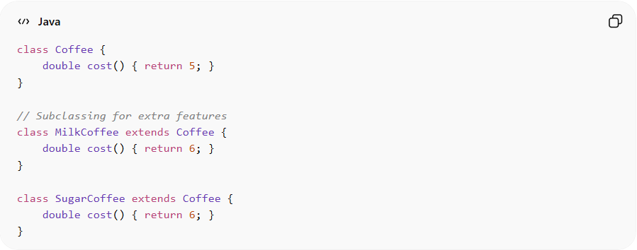
class Coffee {
double cost() { return 5; }
}

// Subclassing for extra features
class MilkCoffee extends Coffee {
double cost() { return 6; }
}

class SugarCoffee extends Coffee {
double cost() { return 6; }
}
Problems:
• Requires many subclasses for each combination
• Hard to maintain when adding new features
• Violates Open/Closed Principle

✅ Good Example
# Source: AI Source: Provided by: [Data Path: Persons Table -> ID Column: 1, Name_En Column: Motasem Essam] -> From: [ChatGPT] on [1/23/2026]
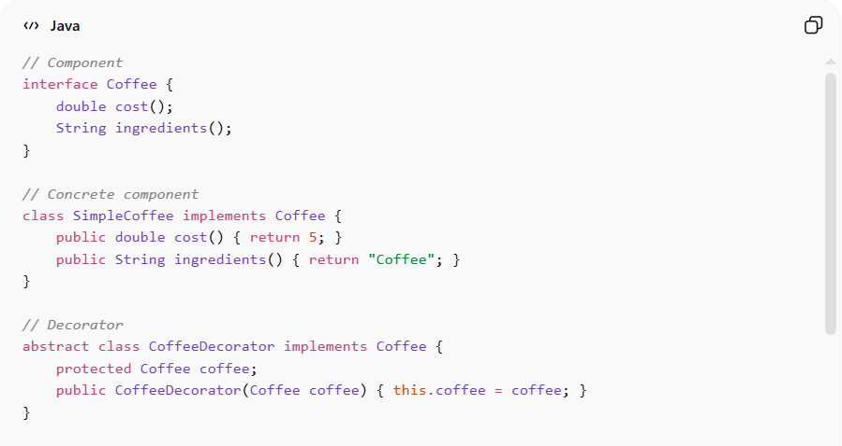
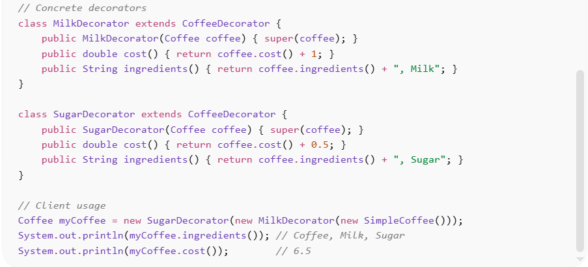
// Component
interface Coffee {
double cost();
String ingredients();
}

// Concrete component
class SimpleCoffee implements Coffee {
public double cost() { return 5; }
public String ingredients() { return "Coffee"; }
}

// Decorator
abstract class CoffeeDecorator implements Coffee {
protected Coffee coffee;
public CoffeeDecorator(Coffee coffee) { this.coffee = coffee; }
}

// Concrete decorators
class MilkDecorator extends CoffeeDecorator {
public MilkDecorator(Coffee coffee) { super(coffee); }
public double cost() { return coffee.cost() + 1; }
public String ingredients() { return coffee.ingredients() + ", Milk"; }
}

class SugarDecorator extends CoffeeDecorator {
public SugarDecorator(Coffee coffee) { super(coffee); }
public double cost() { return coffee.cost() + 0.5; }
public String ingredients() { return coffee.ingredients() + ", Sugar"; }
}

// Client usage
Coffee myCoffee = new SugarDecorator(new MilkDecorator(new SimpleCoffee()));
System.out.println(myCoffee.ingredients()); // Coffee, Milk, Sugar
System.out.println(myCoffee.cost()); // 6.5
Benefits:
• Adds flexible, dynamic behavior
• Avoids subclass explosion
• Maintains single responsibility
• Works well with Open/Closed Principle

⚡ Advantages
# Source: AI Source: Provided by: [Data Path: Persons Table -> ID Column: 1, Name_En Column: Motasem Essam] -> From: [ChatGPT] on [1/23/2026]
• Extends object behavior dynamically
• Reduces need for large subclass hierarchies
• Promotes modular, maintainable design
• Client can choose decorations at runtime

⚠️ Disadvantages
# Source: AI Source: Provided by: [Data Path: Persons Table -> ID Column: 1, Name_En Column: Motasem Essam] -> From: [ChatGPT] on [1/23/2026]
• Can lead to many small decorator classes
• Object composition can become complex and hard to debug
• Client must manage wrapping correctly

🛠️ Use Cases
# Source: AI Source: Provided by: [Data Path: Persons Table -> ID Column: 1, Name_En Column: Motasem Essam] -> From: [ChatGPT] on [1/23/2026]
• Graphical UIs – adding scrollbars, borders, or shadows to windows
• Text processing – applying filters like bold, italic, underline
• I/O streams – Java’s BufferedInputStream, DataInputStream
• Feature toggling – dynamically adding functionality to objects

